Hosting Switch

# DNS Transfer

Transfer the domain name nbaeng.com from Network Solutions to GoDaddy.

This is not technically necessary but it will simplify the management of the domain name and your website if they are both accessible via GoDaddy.com. This transfer is “behind the scenes” and would not be noticed.

The cost for this transfer is $7.99 and in doing this transfer two things will happen:

1. The domain name nbaeng.com will be managed by GoDaddy and you’ll be able to access this domain name using their website.
2. The domain name expiration date will but extended by 1 year. Currently the domain name will expire on May 10 2013. After the transfer the domain name will expire on May 10 2014.

## WhoIs Info

Registrant:  
NBA Engineering Inc  
897 Hyde St. 2nd Floor  
San Francisco, CA 94109  
US  
  
Domain Name: NBAENG.COM  
  
  
  
Administrative Contact, Technical Contact:  
Owens, John jowens@NBAENG.COM  
897 Hyde St. 2nd Floor  
San Francisco, CA 94109  
US  
415.202.9840 fax: 415.202.9838  
  
Record expires on 10-May-2013.  
Record created on 10-May-1999.  
Database last updated on 9-Dec-2012 12:11:49 EST.  
  
Domain servers in listed order:  
  
FLOWER1.MOBILENETICS.COM   
GOLFVIEW.MOBILENETICS.COM  
  
Registrar: NETWORK SOLUTIONS, LLC.  
Whois Server: whois.networksolutions.com  
Creation Date: 10-MAY-1999  
Updated Date: 02-JUN-2008  
Expiration Date: 10-MAY-2013  
  
Nameserver: FLOWER1.MOBILENETICS.COM  
Nameserver: GOLFVIEW.MOBILENETICS.COM  
  
Registry Status: clientTransferProhibited

# Website Hosting Options

As far as hosting… I think the Economy option is sufficient. See the pricing below:

Basically the pricing is between $4.00 and $5.00 per month. You can tons of features (see partial list below and full list here <http://www.godaddy.com/hosting/web-hosting.aspx?ci=76393> ). You could choose the deluxe package if you’d like but I just don’t see the need for it.

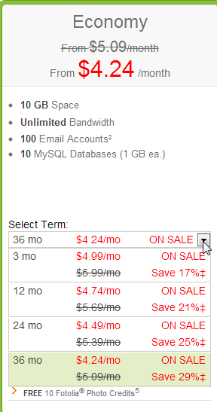

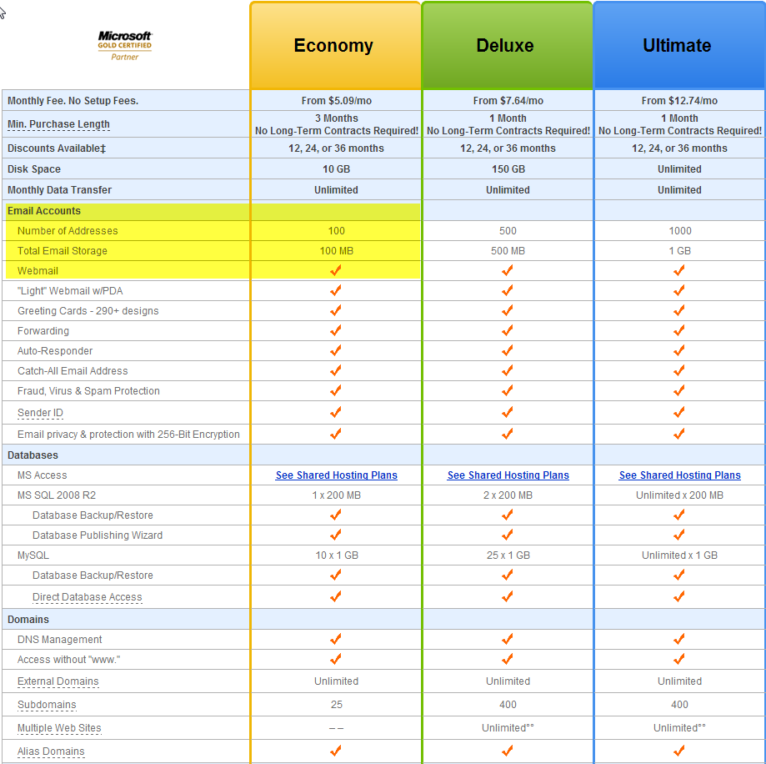

# Email Hosting Options

There are 3 options here.

## Website Hosting Email

Use the Email that is included with your website.

The economy package allows for 100 email addresses and a total storage of 100MB. So you have 100MB of space to allocate over x number of email addresses where x ranges from 1 to 100. For example, if you use 40 email addresses then each box could be a max size of 2.5MB.

The deluxe package allows for 500 email addresses and a total of 500MB.

The thing to remember though is that if you use outlook as your email client then we can configure outlook to connect to the web email and **download** your email. Thus, once the email is downloaded it is no longer stored on the web email server and thus the “space limitation” is not really a limitation. You email is simply downloaded from their server to your computer and deleted from their server. In this situation, if the email is important to you, you should have a backup process in place to back up your outlook data file regularly to keep it safe and so you don’t ever lose your historical emails, etc….

## GoDaddy Web Mail Hosting (Unlimited)

<http://www.godaddy.com/email/email-hosting.aspx>

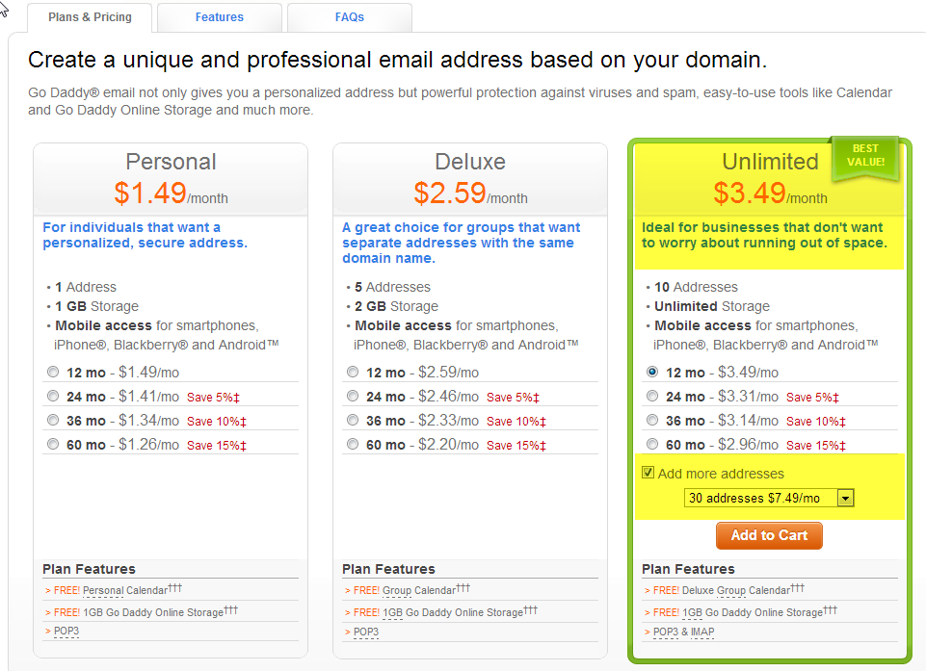

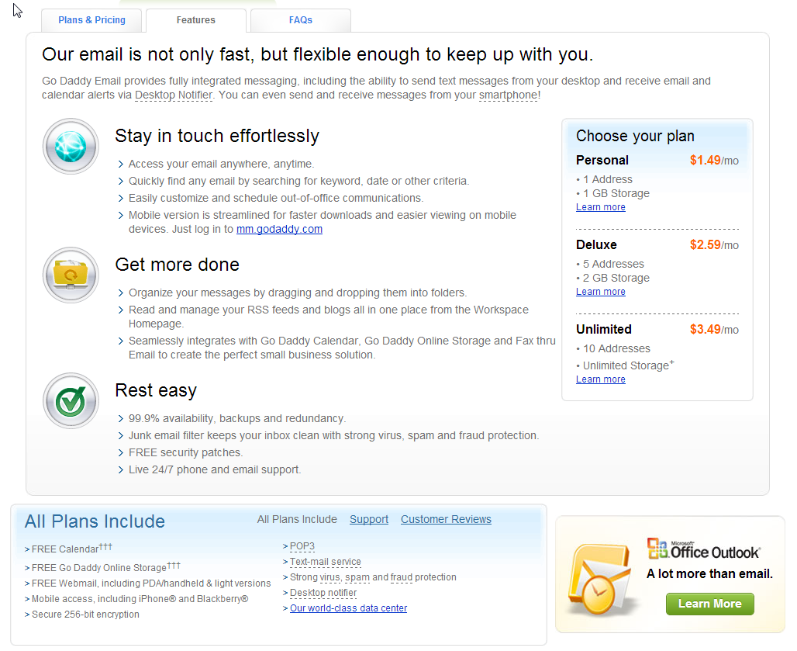

## GoDaddy Hosted Exchange

This option is very pricey and I think overkill. Basically it is a “corporate-class” email solution.

3 email addresses for $30.00 per month.

$6.49 per month for each additional email address.

If you are interested in this option then I could do more research into the advantages of it. But given the cost, I doubt it will be of interest. Or you can research here

<http://www.godaddy.com/email/hosted-exchange.aspx>

# Summary

So, which options to choose? I’d recommend the Economy web hosting package and for email…to cya I’d probably choose the Ultimate email web hosting package. This would be in addition to the website hosting. The ultimate email package would reduce the need of you backing up your own outlook files. It would give you mobile access, etc. and it is not that expensive and gives you more room to “grow” or “work” without issue.

1 year contract with website hosting and ultimate email package is approximately 168.93 or $14.08 per month. Plus a 1 time 7.99 domain name transfer.

3 year contract with website hosting and ultimate email package is approximately 478.06 or $13.28 per month. Plus a 1 time 7.99 domain name transfer.

This pricing includes a 15% promo code that I have for GoDaddy and would share with you (**GDX1219E ).**

